**SVKM'S NMIM’S Nilkamal School of Mathematics, Applied Statistics & Analytics**

**Master of Science (Data Science)**

Practical-7 **Webfeed**

Open xamp panel

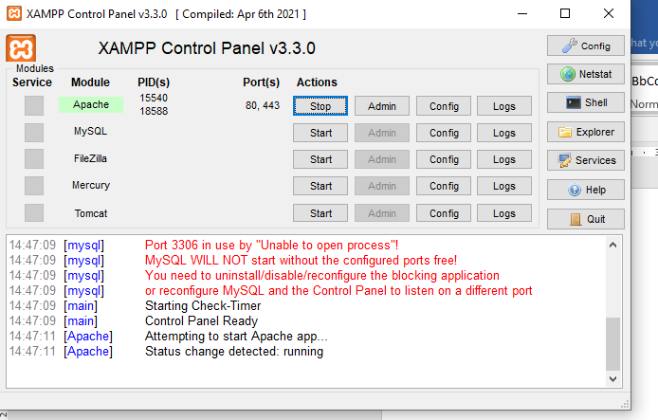

Verify using localhost

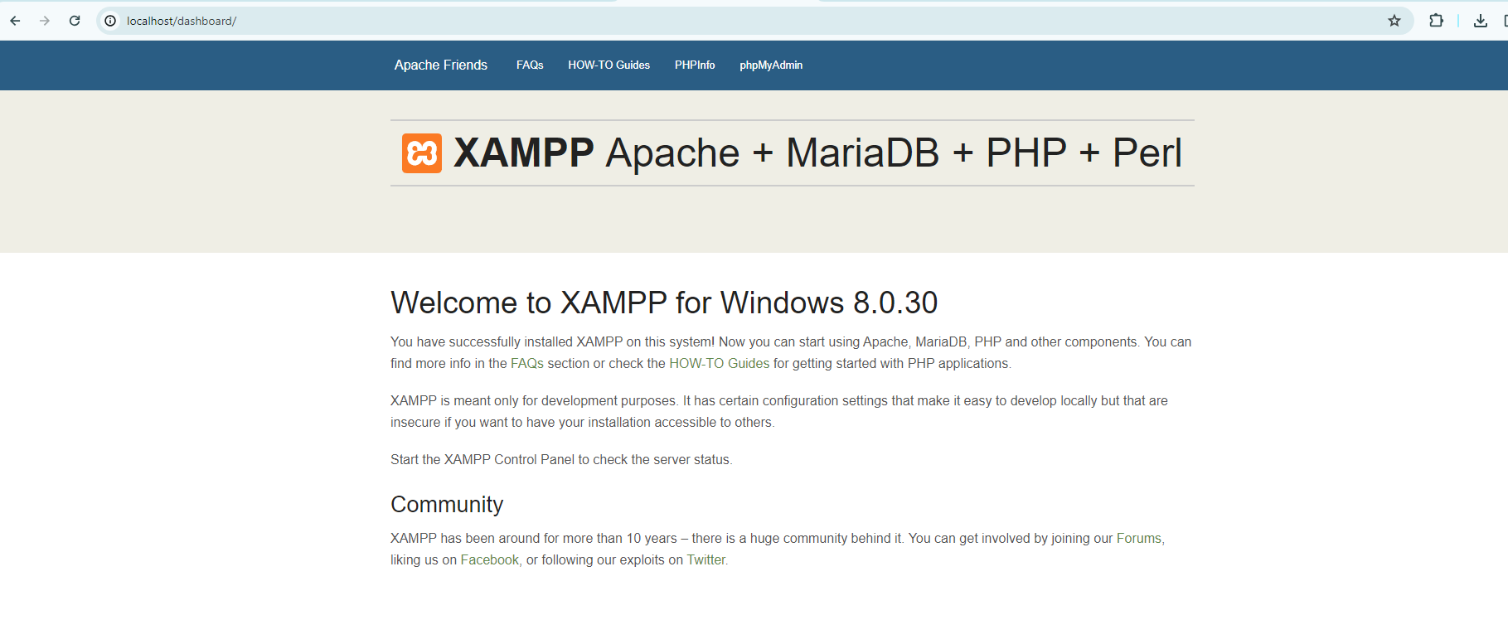

Login in mysql cmd

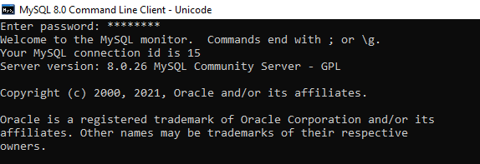

Create a database

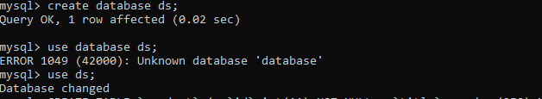

Create a table and add values

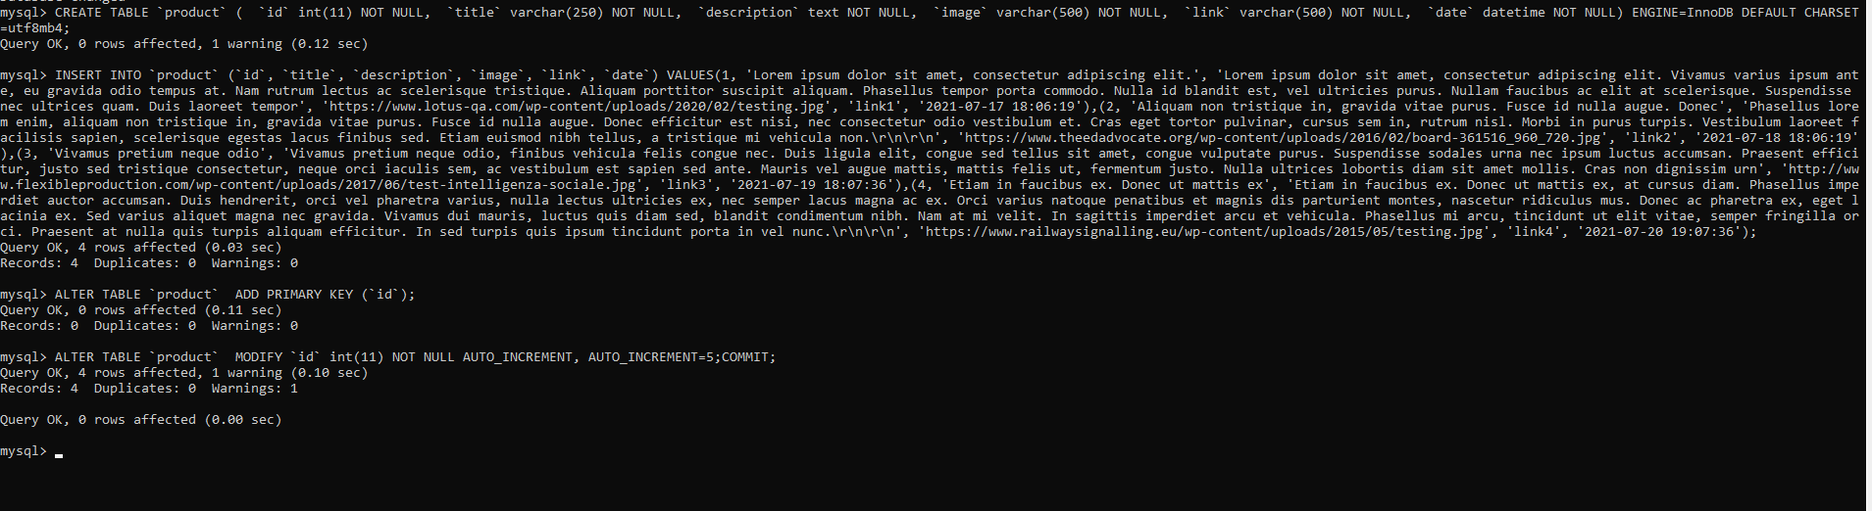

Paste the files in following folder

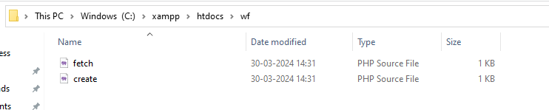

Load wf



Replace the url with whatever you want

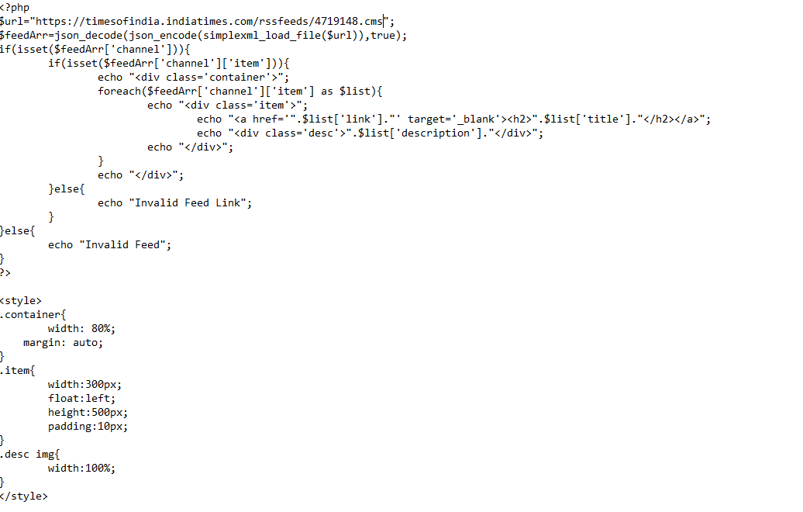

Click on fetch and check if the link works

